SOLUTIONS ARCHITECTING ON CLOUD

(20CS3235AA)

Labs-8

Name: K. VENKATA SREE SAI

ID:2000030439

**Create and Connect to a MySQL Database, Dynamo DB ,Create an on demand backup job of an Amazon RDS database**

Create and Connect to a MySQL Database:

1. Sign in to the Amazon Web Services (AWS) Management Console

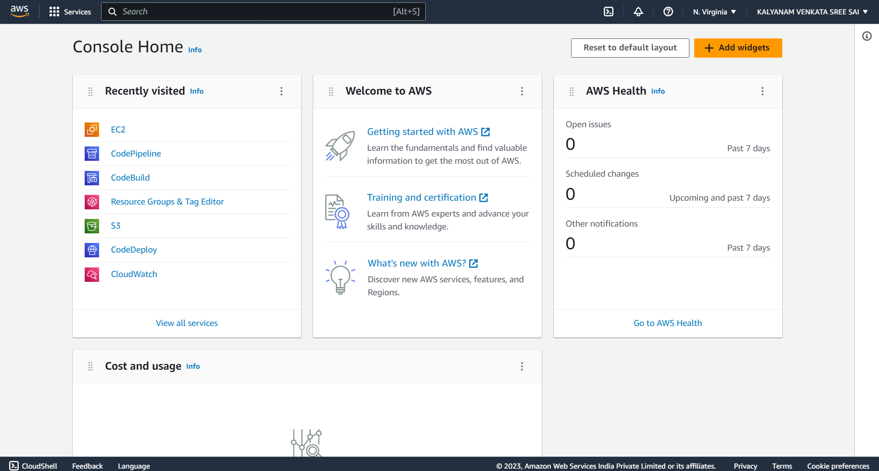

1. Navigate to the **Amazon RDS** dashboard.

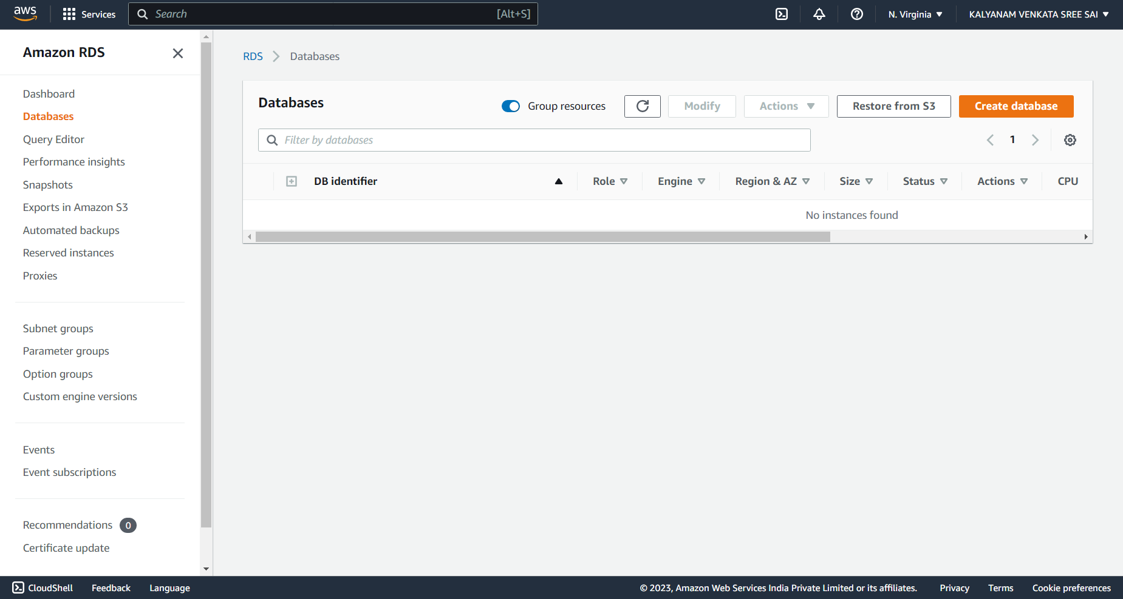

1. Click the "Create database" button.

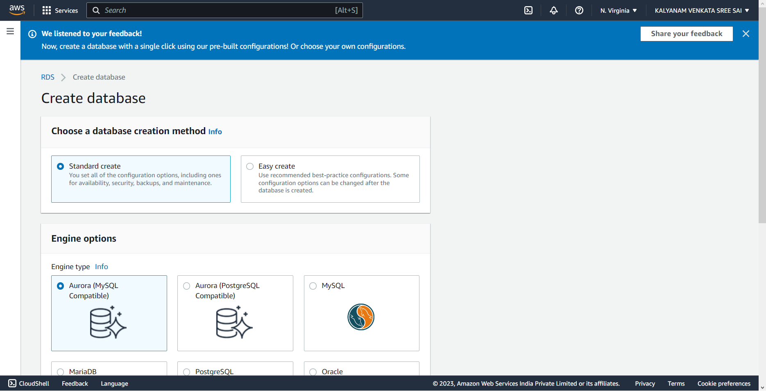

1. Choose the MySQL engine.

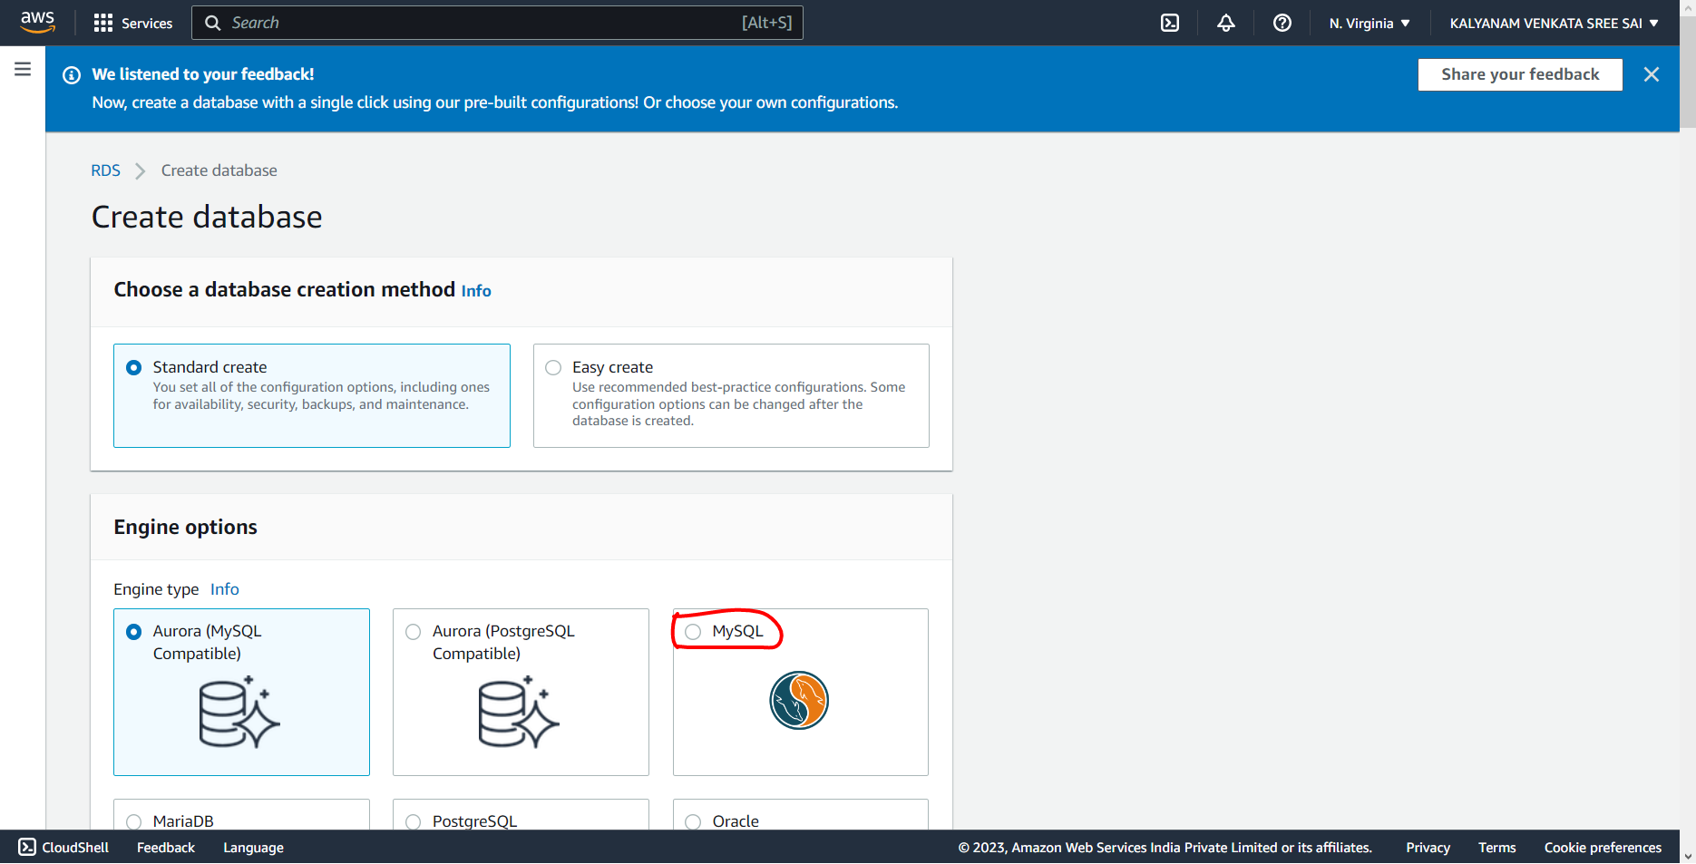

1. Choose the deployment type and specify the details for your database instance, including instance class, storage, and network settings.

1. Configure the database options, including the database name, username, and password.

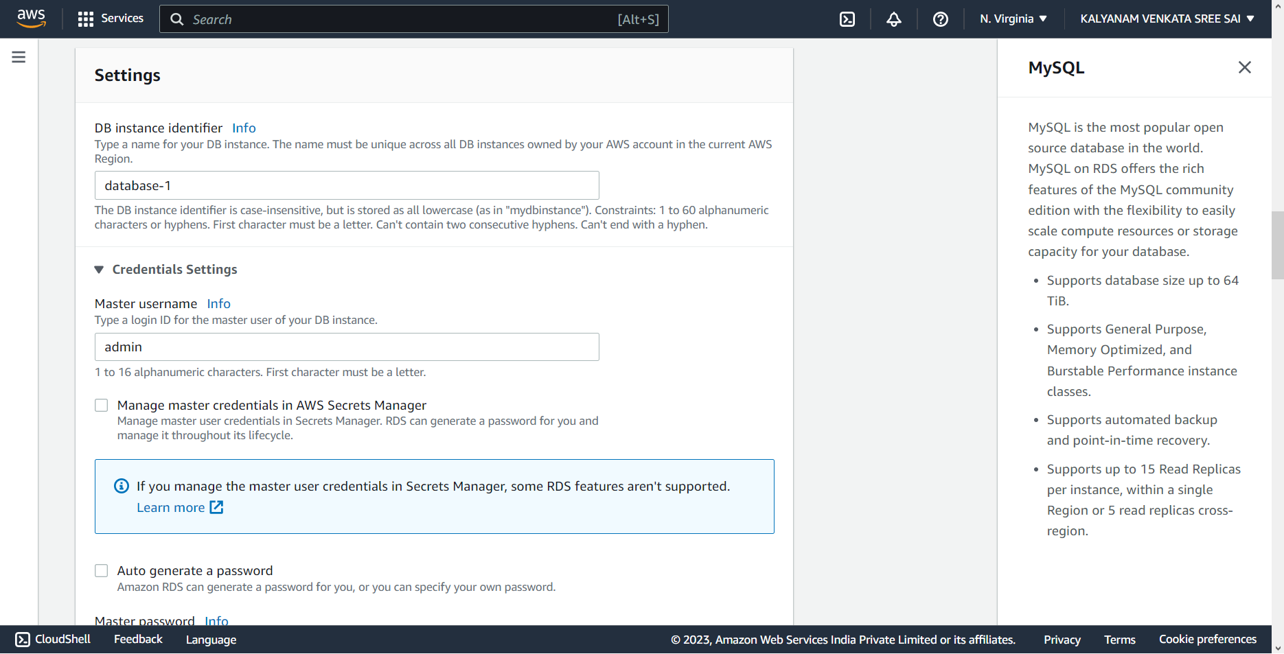

1. Click the "Create database" button to create your MySQL database.

